Documentação do layout

1. 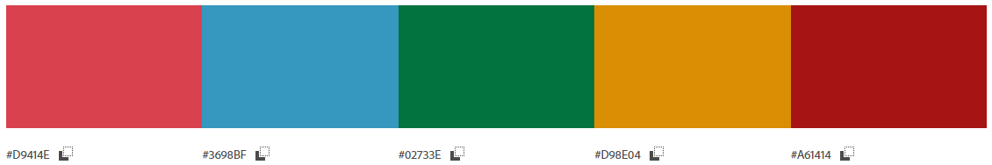Paleta de cores:
2. Fontes:

**Super Mario 256**

<https://www.dafont.com/pt/super-mario-256.font>

**Super Mario Bros**

<https://www.dafont.com/pt/super-mario-bros.font>

**Super Mario Bros. 3**

<https://www.dafont.com/pt/super-mario-bros-3.font>